Announcement of Superintendent Search
Application Deadline: November 20, 2014

The Williston 29 School District has retained the South Carolina School Boards Association to assist in the search for the new superintendent. The Board of Trustees of the Williston 29 School District invites applications and nominations for the position. The anticipated date of hire is March 1, 2015.

The Search
All candidates should be able to demonstrate a proven record of exceptional leadership with the following additional qualifications.
- A leader with a vision of educational excellence, who will work cooperatively with the Board of Trustees to build relationships with students, staff, parents and the community to achieve academic excellence for all students.
- A leader who has the ability to analyze current situations, initiate appropriate action, inform the Board of Trustees when advisable, and who will provide leadership in the development of short-and long-term goals for the district.
- A visible, accessible, approachable leader who is committed to building mutual respect and trust and serving as a model and mentor among staff.
- An articulate communicator with strong interpersonal skills, demonstrated ability to work creatively, effectively, and visibly with board members, staff, students, parents and the community.
- A person who understands the complexities of school finance, has the ability to interpret educational and financial data, and who will maximize the use of resources in support of the educational programs of the district.
- An administrator with a thorough knowledge of and successful experience in school district management including information technology, staff development, program assessment, accountability measures and school improvement.

The Application
Candidates are requested to submit all of the following:
- A letter of application indicating interest in this position
- A completed application form; including the Applicant’s Statement section (available at www.scsba.org)
- A current resume
- Three recent letters of reference written within the last six months

Send application materials and direct all inquiries to:
Judy LeGrand
SC School Boards Association
111 Research Drive
Columbia, SC 29203
803-988-0226
Williston29search@scsba.org

Applicants must have a Specialist degree or higher in education with an emphasis on school administration from an accredited college or university; doctorate preferred. Applicants must be eligible for certification as a superintendent in South Carolina. If you do not hold a South Carolina superintendent’s certificate, please contact: the Office of Educator Licensure, South Carolina Department of Education, 803-896-0325, licensure@ed.sc.gov. Applicants will be required to
demonstrate their ability to meet all certification requirements prior to finalist interviews being conducted.
.

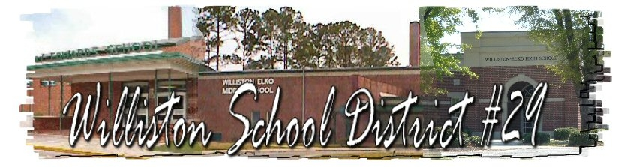

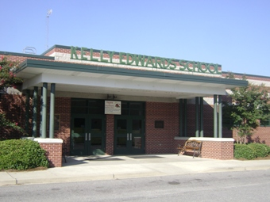
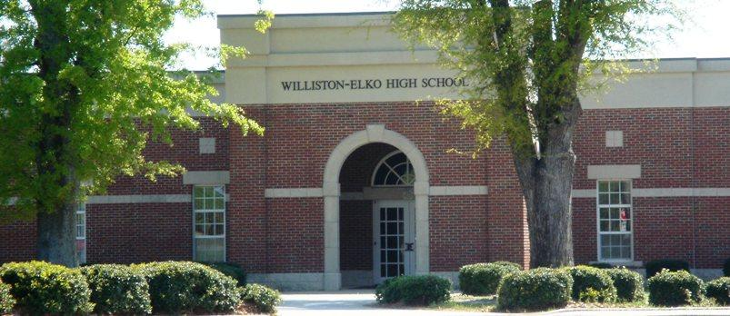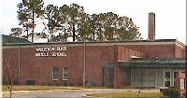

The District
The district has three schools: Kelly Edwards Elementary School, Williston-Elko Middle School, and Williston-Elko High School. The district has approximately 928 students and employs 144 people. The annual operating budget is approximately $7,299,472. The average teacher salary is $46,908 and the average years of experience of their teachers are 12.8 years. The district has one National Board Certified Teacher. All public schools in Williston 29 are fully accredited by the State Department of Education and the Southern Association of Colleges and Schools. Williston Elko High School earned an honor making Newsweek’s annual list of top high schools. (The school rated #322 out of 500 among schools that best prepare students for college.)

The Board of Trustees
Billy Williams, Chair
Ferlecia Cuthbertson
Michael Hutto
Charles Melton
Doris Young

Vision: As a united faculty and community, we facilitate respectful and productive citizens.
Our mission is, with the support of parents and the community, to develop caring and productive citizens by
providing challenging and enriching experiences in a safe environment

The Community
Williston is a town in Barnwell County, South Carolina. The population was 3,307 at the 2000 census. The town lies in the center of the Charleston-Hamburg railroad line, the line of the Best Friend locomotive. The train tracks were removed in the 1990s, however, the track site has been designated as historically significant by the South Carolina Department of Archives. This section of the train route is now the route of the South Carolina Heritage Corridor. The town has a land mass of 8.95 square miles. In 1670, this area was probably an Indian village. It is thought that Hernando de Soto journeyed just North West of this area on his trek from Savannah to the Mississippi River (1539-1540).

